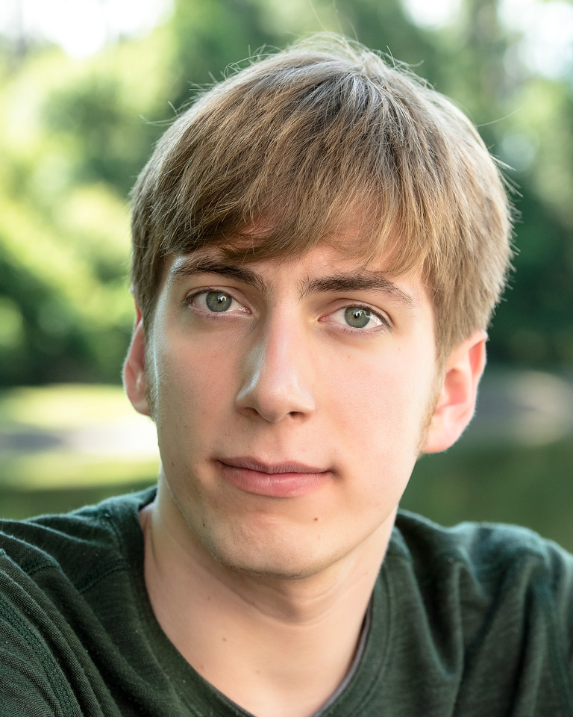

Jordan Bertke
Phone: 727-656-6144
Email: jordanbertke@hotmail.com
Voice: Bari-tenor Height: 6’
Eyes: Blue/green Hair: Dark Blonde

Professional Theatre
Murder on Blueberry... Donny B. Susan Nichols 2nd Stage Theater
Blind Double Date Greg Self-Directed Airtight Theatre
Creatures of the Night Barnacle Barney JC York ZooTampa
The Friendzone Todd Self-Directed Airtight Theatre
Christmastown Bumble Tim Brown Busch Gardens, Tampa FL
Echo Nevada John C. Anna Brennan ArtsFusion
The Fairy Home Comp… Performer Tom Barker Una Voce

Other Theatre (Selected)
My Big… Irish Funeral Ryan “Rono” Maher Madison Rice Carrollwood Players
Bye Bye Birdie Bartender (Voice) Brianna Larson Theatre eXceptional
Urinetown Lockstock Scott Cooper SPC Theatre
She Kills Monsters Miles Dan Granke USF Theatre
Machinal Various Dora Arreola USF Theatre
Oliver! Dr. Grimwig (Voice) Brianna Larson Theatre eXceptional
Fiddler on the Roof Lazar Wolf Scott Cooper SPC Theatre
Sweet Charity Ensemble Doug Hall USF Theatre
Little Shop of Horrors Orin/Mrs. Luce Scott Cooper SPC Theatre
Zombie Prom Jonny Warner Scott Cooper SPC Theatre

Technical Theatre
Blind Double Date Playwright, Director Airtight Theatre
Elf Jr. Director East Lake High School
The Friendzone Playwright, Director Airtight Theatre
Internship Various Positions Tiffany Ford American Stage Theatre
S.P.A.R. Director East Lake High School

Education
Dance Alison Burns-Jackson West Florida Dance Center
Voice Michelle Smith-Sund Tarpon Springs
B.A. Theatre Marc Powers University of South Florida
A.A. Theatre Scott Cooper St. Petersburg College
Voice Edward Crader Ruth Eckerd Hall

Skills
Stage Combat Certified: Unarmed, Single sword with recommendation
Puppet Experience Strong Falsetto
Playwriting Swimming
Unicycling Tightrope experience

